**Before all:**

* Look for your spelling, avoid abbreviations
* Think twice: is this really want I want to writer? Is this existing in reality?
* Do not fill filed where there is nothing to fill in, also not with Nil or so
* If there is something special (e.g. two banking accounts, a special tile..) please do not try to write it into the form, ask the administrator, he surely will assist you and and give helpful advice

**Personal details**

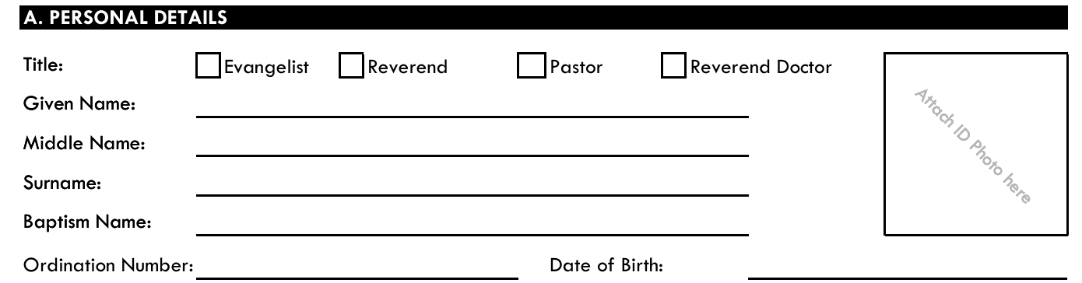

This is easy and not much rules:

* All kinds of names start with capital letters and following lower letters:
  + Michael, not MICHAEL, not michael
  + No other checking

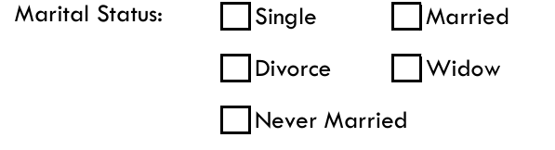

Just check careful

* The difference between Single and Never Married is: a person under the age of 40 is a single, only a person above 40 can be Never Married

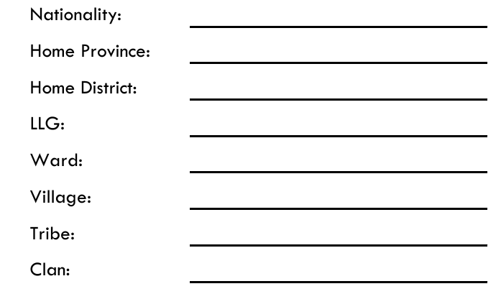

* Nationality in most cases will be PNG
* For province, District and LLG take the real name, no abbreviation, not the capital but the name
  + Kamtai is wrong it’s the capital of Chimbu Province
  + Write Chimbu and not chimbu or CHIMBU
* War is always a number: 10, 19, 17….

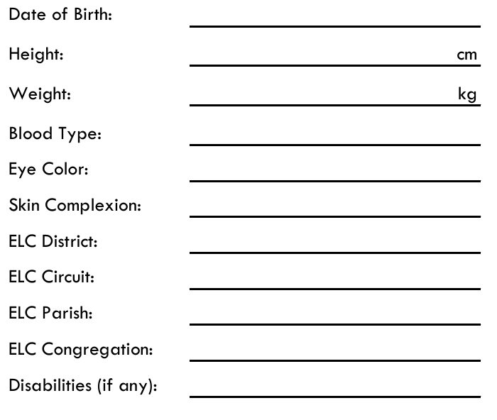

* Date of Birth: the correct format is yyyy/mm/dd which means:
  + 4 digit year, e.g. 1975
  + 2 digit moth, e.g. 4 for Pail
  + 2 digit day, e.g. 12
  + Separated by /
* Attention: weight and height are already with an unit of measurement
* Check the number you insert here: is the pastor really 40 cm high? ☺
* Blood types can be 0, A,B and AB
* Eye color like brown, black in lower letters
* Skin complexion: Very Fair – Fair – Medium – Olive – Brown -Black
* ELC District/Circuit/Parish/Congregation: take an existing unit in correct spelling, e.g. Jabem - Lae City - Redeemer – Komesel
* Disabilities: free

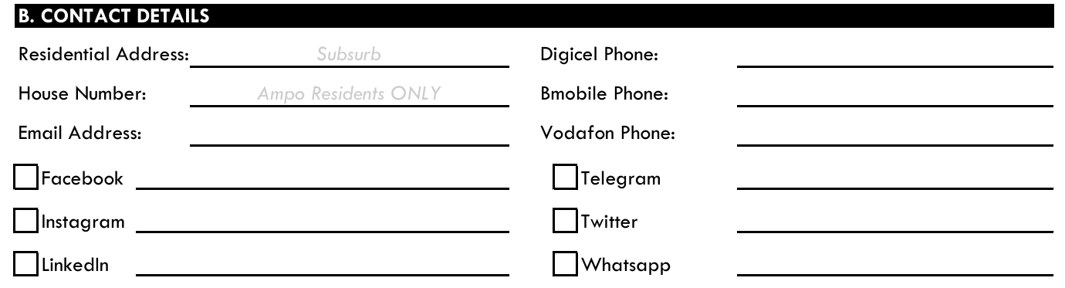

* Residential address: free only suburb no more details
* House number only for Ampo
* Facebook/Instagram/LinkedIn/ Twitter(now X): social media presence, cross for yes, specific information is helpful
* Digi cell/Bmobile/Vodafone: phone number starting with (675)
* Telegram//WhatsApp: cross for yes, specific information is helpful

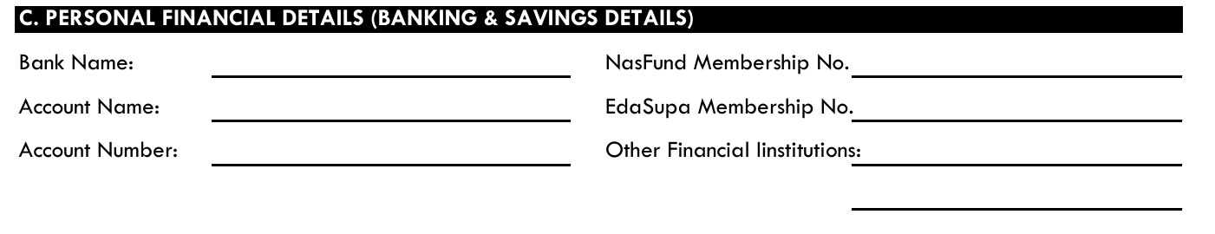

* Banking name: we love abbreviations: so write BSP for the most popular bank, no addition of city needed because if someone moves it will change.
* Account number: **one** number nothing else

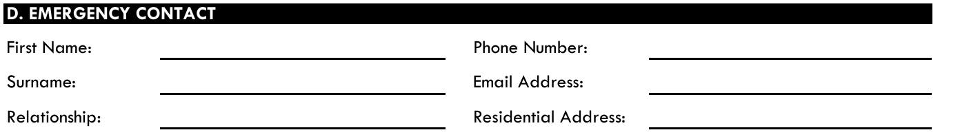

Same rules than for all other items

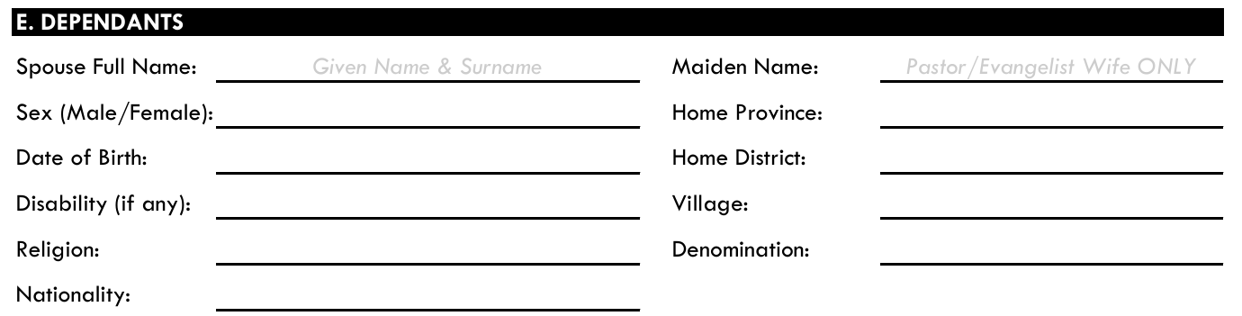

* Name: free
* Sex: M for male, F for Female
* Date of Birth: the correct format is yyyy/mm/dd which means:
  + 4 digit year, e.g. 1975
  + 2 digit moth, e.g. 4 for Pail
  + 2 digit day, e.g. 12
  + Separated by /
* Religion: in almost any case this will be Christian, please write it this way
* Denomination: in almost any case this will be Lutheran, please write it this way
* Look for write spelling of Province, district and so on



Here you can fill in up to 8 dependent persons as sons and daughters. Please do not fill information about the spouse in the dependents block.

* If it’s the 1st Son just set it on the lowest possible number (e.g. #1), this shows he is first
* The rules for the date have to be applied here as well

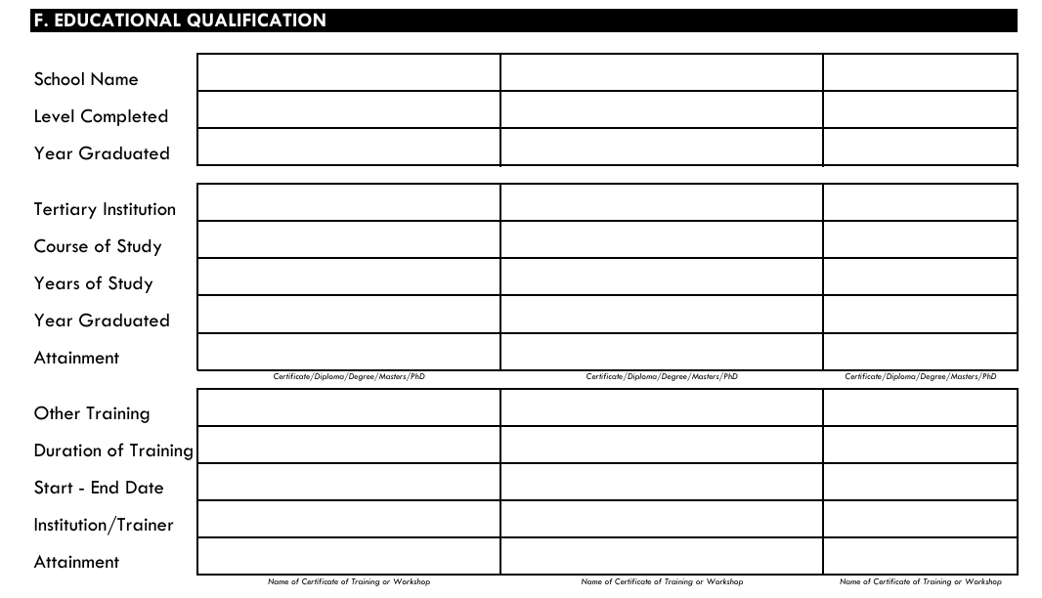

* It’s simple: year is one year, not a period: years is normally a period e.g. 1998 – 2000
* Keep an eye on School name, tertiary institution, course of study and so on: did I spell it right? Does it exist under this name?
* It’s not “Muaina high sch” or “YUFETO COMM. SCHOOL” or similar, “Banz Lutheran Primary School” looks perfect.

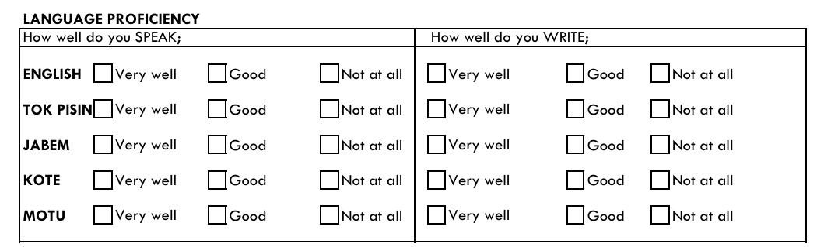

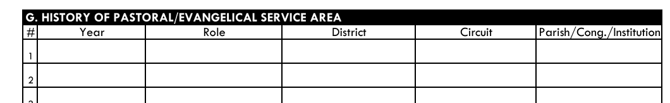

* Here also please look for correct spelling of items and check if they are really existing e.g. is this a district?
* 1999-24 is not correct for year but 1999 – **20**24 is, a year has four digits
* 2020 Jan-October does not fit here, it’s in this case just 2020

